* **Project Name:** FitJourney AI
* **Abstract:**

FitJourney AI is an intelligent fitness tracking app designed to help users achieve their health goals efficiently. By allowing users to log workouts, monitor progress, and receive AI-driven recommendations, the app provides a personalized fitness experience. Users can input key details like weight goals and workout data, while AI suggests optimized routines to improve performance. With a clean interface and smart analytics, FitJourney AI makes fitness tracking seamless and motivating.

* **User Stories:**

1. User Profile & Goal Setting:  
   As a **user**, I want to **input my personal details and set fitness goals**, so that **I can track my progress and work towards my target weight**.
   1. The user can enter their **full name, age, height, current weight, target weight, start date, and end date** in a form.
   2. The entered information is displayed as a **summary at the top** of the app.
   3. The user can click an **edit button** and let the user update any field if needed
2. Workout Entry & Logging:  
   As a **user**, I want to **log my workouts** by entering key details, so that **I can track my progress over time**.
   1. The user can select the date of the workout.
   2. The user can choose between **walking, running, or cycling** as a workout type.
   3. The user can input **distance (km/miles), duration (minutes), and calories burned** for each workout.
   4. The workout entries are stored and displayed in a **list format inside a container**.
3. Filtering & Managing Workouts:  
   As a **user**, I want to **filter and delete my workouts**, so that **I can easily manage my workout history**.
   1. The user can **filter workouts** by type using checkboxes (Walking, Running, Cycling).
   2. The user can **delete any logged workout**, and it will be removed from both the list and data storage.
   3. When a specific filter is selected, the summary will also be updated
   4. When a workout is deleted, the summary will also be updated
4. AI-Powered Workout Suggestions:  
   As a **user**, I want to **receive AI-powered workout suggestions**, so that **I can optimize my workouts and reach my goal efficiently**.
   1. The AI can analyze the user’s **goal, remaining time, and past workouts** to suggest an **optimal next workout** (type, distance, duration, and calories needed).
   2. The AI-generated workout suggestions update **dynamically based on progress**.
5. UI/UX & Responsiveness:  
   As a **user**, I want a **clean, user-friendly, and mobile-responsive app**, so that **I can navigate easily and track my workouts on any device**.
   1. The app is **mobile-friendly** and works on different screen sizes.
   2. The design is **clean and easy to navigate**, with clear buttons for adding and deleting workouts.

* Trello Link: <https://trello.com/b/Wbv4M8gO/paul-project-2-ai-integration>
* Wireframes
  + Main wireframe

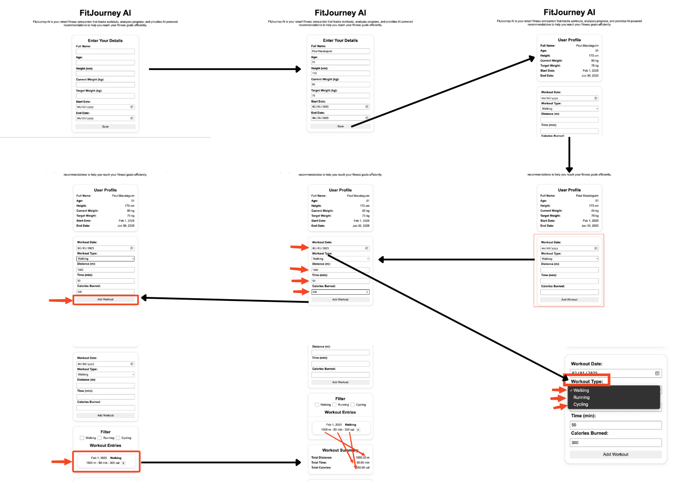

* + Filter Feature

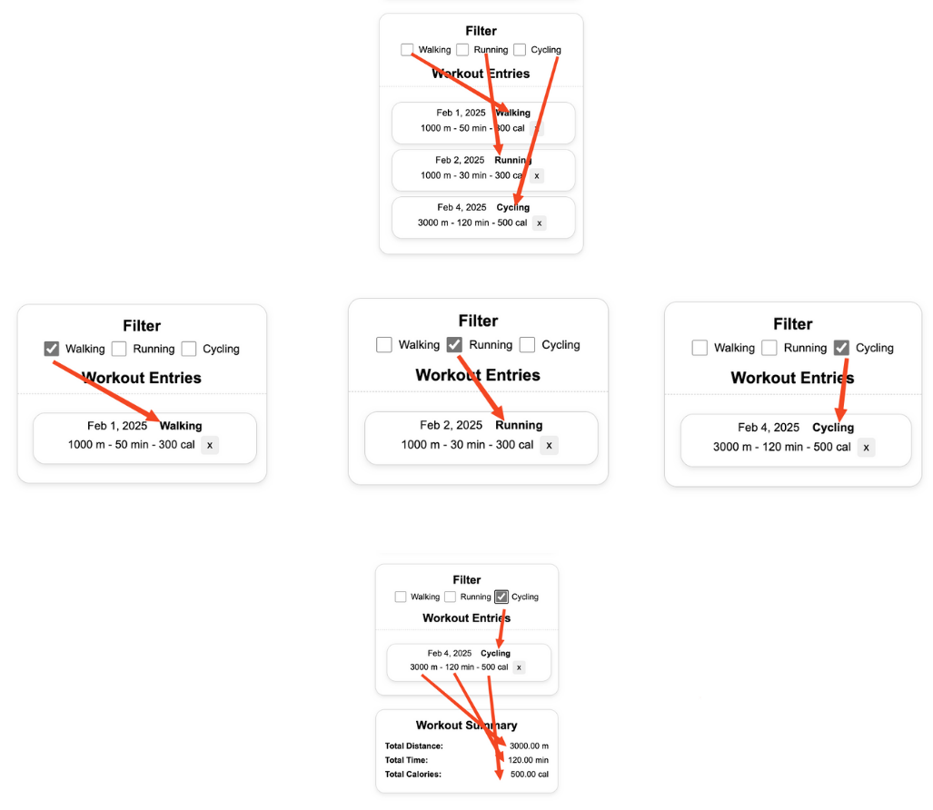

* + Delete Feature

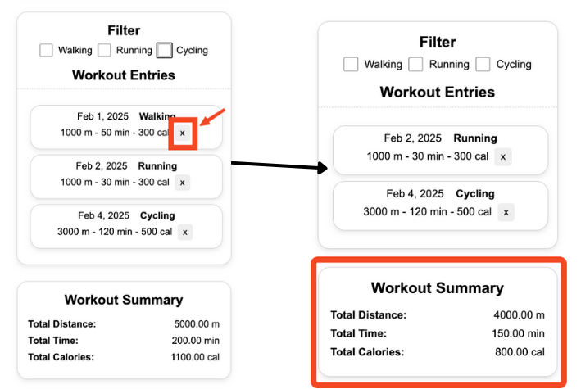

* + AI Feature

